SACRED HEART PARISH

Sacred Heart Parish Founded 1814, The First Catholic Parish in the STate of New Jersey

Sacred Heart Church, 343 South broad Street, Trenton, New Jersey 08608

Holy Cross Church, 233 Adeline Street, Trenton, New Jersey 08611

ALL ARE WELCOME

Whatever your present status in the Catholic Church, whatever your current family or marital situation,

Whatever your past or present religious affiliation, whatever your personal history, age, background, or

race, whatever your own self-image or esteem, you are invited, welcomed, accepted, loved and

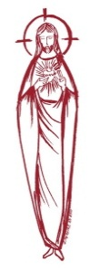
respected at the Parish of the Sacred Heart.

PASTOR

Rev. Msgr. Dennis A. Apoldite
frdennis@trentonsacredheart.org
PAROCHIAL VICAR
Rev. Charles Muorah
Felician Residence for Clergy
233 Adeline Street, Trenton, New Jersey 08611
609-393-4826 ext. 108 for Fr Charles
DEACON
Dr. Christian Nnajiofor
Business ADMINISTRATOR
ADMINISTRATIVE ASSISTANT
John DeSantis: secretary@trentonsacredheart.org
Administrator of religious education
Mary Tovar: reled@trentonsacredheart.org
COORDINATORS OF SACRED MUSIC
Natalie Megules ~ 609-575-6484
Rupert Peters ~ Gospel Mass 609-442-7871
MAINTENANCE DEPARTMENT
Frank Rios
Trustees
Jack Breuer and Ellieen Ancrum Ingbritsen,

OFFICE HOURS

9:00am – 4:00pm Monday – Friday

SACRED HEART PARISH OFFICE

343 South Broad Street, Trenton, NJ 08608

Phone: (609) 393-2801 ~ Fax: (609) 989-8997

WEB PAGE:

www.trentonsacredheart.org

CEMETERY RECORDS
Contact The Office of Catholic Cemeteries at 609-394-2017 or DirectorofCemeteries@DioceseofTrenton.org

SACRAMENTAL RECORDS
Sacred Heart Church, Saint John’s Church, Saint Francis Church, Saints Peter and Paul Church, Saint Stanislaus Church, Holy Cross Church, Blessed Sacrament Church, Our Lady of Divine Shepherd Church, Blessed Sacrament/Our Lady of Divine Shepherd Parish and Divine Mercy Parish.

Liturgy Schedule

Sacred Heart CHURCH
Monday, Tuesday, Wednesday and Friday
12:10 Noon
Saturday Evening 5:15 PM
Sunday Morning 9:00 and 11:15 AM
HOLY CROSS CHURCH
Monday, Thursday and Friday 8:00 AM
Saturday Evening 4:00 PM
Sunday Morning 10:00 AM Gospel
12:00 Noon Polish
For each Holy Day please reference the bulletin

SACRAMENTS
BAPTISM
Please call the Parish Office at least one month in advance.

RECONCILIATION

Every First Friday following the 12:10PM Mass SHC

Saturday afternoon ~ 4:30 to 5:00 PM SHC

Every Saturday from 3:30 to 3:50 PM HCC

Every Sunday 9:30 to 9:50AM HCC

and by appointment.
EUCHARISTIC ADORATION
First Saturday of the Month 2:30 to 3:30 pm
in Holy Cross Church
MARRIAGE
Please call the Parish Priest at least one year in advance to set up initial meeting and to confirm a wedding
date and time.
ANOINTING OF THE SICK
Please call the Priests any time 609-393-2801.
COMMUNION TO THE HOMEBOUND
Call the Parish Office to schedule home visit.
CONSIDERING PRIESTHOOD?
Email: Vocations@DioceseofTrenton.org

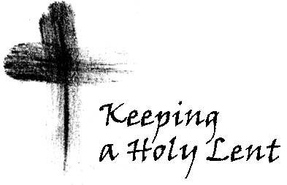

PALM SUNDAY OF
THE PASSION OF THE LORD

March 24,2024

MASS INTENTIONS
Saturday, March 23
4:00pm HCC~ For Glazewski Brothers
5:15 pm SHC ~ Robert Breese & Lois Hills Kost
Sunday, March 24
9:00 SH ~ Alexander Chernichov, Victor Ladnyk,
and John Ladnyk
10:00HCC~ The intentions of the People of the Parish
11:15 SH ~ Helen Potash & Helen Smith
12:00 HCC Polish ~ Zbigniew Mazanek
and Jozef Dworakowski
Monday, March 25
8:00 HCC ~ Special Intentions
12:10 SHC~ Lottie Kostrzewa
Tuesday, March 26
12:10 pm SHC ~ Francis X. Fahey
Wednesday, March 27
12:10 pm SHC ~ Joseph A. Bellina
Thursday, March 28 ~ HOLY THURSDAY
7:00 pm SHC ~ People of the Parish
Friday, March 29 ~ GOOD FRIDAY
3:00 pm HCC English
7:00 pm HCC Polish
Saturday, March 30 ~ EASTER VIGIL
7:30 pm SHC ~ People of the Parish
Sunday March 31 ~ EASTER SUNDAY
6:45 HCC Polish ~ Special Intentions
9:00 SHC ~ Special Intentions
10:00 HCC ~ Special Intentions
11:15 SHC ~ Special Intentions
12:00 HCC Polish ~ Special Intentions

OUR SICK LIST
Karen Staffini, Arlene M. Brodowski, Beth Fitzpatrick, Judy Brown, BJ Matthews, Marg Herpel, Jose Gonzalez, Mary Sokolowski, Rocco, Lorraine Wargo, Robert Paci, David Carver, Jennifer Lyons, Grace Profy, Steve Jurczynski, Cornell Hess, Ruby Covington, Judith Santigo, Dan Breese Jr, Brenna Kennedy-Moore, Mark Friedman, Alexander A. Ladnyk, Lauren Clayton, Joseph Edralin, Margie Tiongson, Vincent Cooper, Jr., Gail Ladnyk, Leo Genovesi, Richard Buckley, Tony Ragolia, Barbara Burrows, Charles Burrows, Dorothy Amoroso, Maryann Sullivan, Regina Friedman, Stanley Winowicz, Greg Schafer, Jack Hardiman, Amy Birk, Julia Grazioli, Matt Tydryszewski.
OUR DECEASED
Jack Hardiman, John Warren and our friends at South Village, Riverside Nursing and Rehabilitation Center, Mill House and Waters Edge.

MINISTRY SCHEDULE
(Subject to Change)

Saturday, March 23
4:00pm HCC ~ Fr Charles L.: R. Micharski and M Herpel
Em.: L. Bliznawiczus
5:15pm SHC ~ Msgr. Dennis L.: R. and C Hernandez
Em.: K.&S. Farruggio
Sunday, March 24
9:00 SHC ~ Msgr. Dennis L.: M. Komjathy and R Paci
Em.: H.&M. Figueroa, A. Green
10:00 HCC ~ Fr. Charles L.: D. Wilson Em.: M. Williams
11:15 SHC ~ Msgr. Dennis L.: J. Blizard and K Jurczynski
Em.: B. Allaire, J. Bautz
12:00 HCC Polish ~ Fr Marian

WEEKLY COLLECTION
Last weekend’s collection amounted to $8,401.00. This includes the donations received in Church and the mail ins. Thank you for your continued support of our parish.

2024 ANNUAL CATHOLIC APPEAL UPDATE
Goal: $33,000.00 :
Pledged: $13,238.00 (40% of Goal)

READINGS FOR THE WEEK
Week of Palm Sunday of the Passion of the Lord
Sunday Jn 12:12-16;; Phil 2:6-11; Mk 14:1—15:1-39
Monday Is 42:1-7; Jn 12:1-11
Tuesday Is 49:1-6; Jn 13:21-33, 36-38
Wednesday Is 50:4-9a; Mt 26:14-25
Thursday Ex 12:1-8, 11-14; 1 Cor 11:23-26; Jn 13:1-15
Friday Is 52:13—53:12; Heb 4:14-16,; Jn 18:1—19:42

PROMISE TO PROTECT
The Diocese of Trenton is committed to the norms of the U.S. Bishop’s Charter for the Protection of Children and Young People in regard to the reporting and investigation of sexual abuse allegations involving minors. If you have been sexually abused as a minor by anyone representing the Catholic Church, you can report that abuse through the diocesan Hotline: 1-888-296-2965 or abuseline@dioceseoftrenton.org. Allegations are reported to the appropriate law enforcement agencies.

PALM SUNDAY
RELIGIOUS EDUCATION FAMILIES
The families of our Religious Education students will gather at the 11:15 Mass on Palm Sunday. The students will process into church and present palm branches at the foot of the Altar.

LENT
MERCER COUNTY LENTEN PILGRIMAGE
Week of March 24
Thank you to all who participated in Mercer County Program this Lenten Season. Our final visit will be Monday, March 25 ~ St. Robert Bellarmine Co-Cathedral,(7:30PM)~61 Georgia Rd, Freehold,

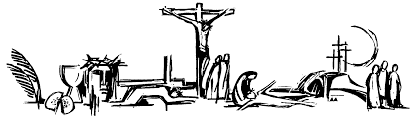

March 24 PALM SUNDAY OF
THE PASSION OF THE LORD
Is 50:4-7/Phil 2:6-11/MK 14:1-15:47
~Sacred Heart: Mass celebrated at 9:00 & 11:15
Holy Cross Church: Mass celebrated at 10:00am (Gospel Mass) 12:00 Noon (Polish Mass)
The Lamentations will follow the Mass

March 25 Monday of Holy Week
Is 42:1-7/Jn 12:1-11
~Holy Cross Church Mass celebrated at 8:00am
~Sacred Heart Church Mass celebrated at 12:10
Chrism Mass:
7:30 pm at St. Robert Bellarmine Co-Cathedral
61 Georgia Rd, Freehold, NJ

March 12 Tuesday of Holy Week
Is 49:1-6/Jn 13:21-33, 36-38
~ Sacred Heart Mass celebrated at 12:10 noon ~
Sacred Heart Church Confessions 5:00 to 6:00pm.

March 26 Wednesday of Holy Week
Is 50:4-9a/Mt 26:14-25
~Sacred Heart Mass celebrated at 12:10 noon
~Holy Cross confessions 5:00pm to 6:00pm

March 27 Holy Thursday of Holy Week
Evening Mass of the Lord’s Supper
Ex 12:1-8, 11-14/1 Cor 11:23-26/Jn 13:1-15
7:00 pm at Sacred Heart Church, following the Mass the Eucharist will be taken to Holy Cross Church and placed in the Repository. ~Holy Cross Church will remain open till 10:00PM. ~Sacred Heart Church will close after the evening Mass.

March 28 Good Friday of
the Passion of the Lord
Is 52:13—53:12/Heb 4:14-16;/Jn 18:1—19:42
Day of Fast and Abstinence ~
El Centro Outdoor Bilingual Stations ~
10:00 AM begins in front of Sacred Heart Church and ends in front of Holy Cross Church
Liturgy of the Lord’s Passion
3:00 pm at Holy Cross Church
and 7:00 pm (Polish) at Holy Cross Church

March 29 Holy Saturday
Blessing of Food
Holy Cross Church ~ 12:00 noon
Easter Vigil Liturgy ~ 7:30 pm at Sacred Heart Church

March 30 EASTER SUNDAY OF
THE RESURRECTION OF THE LORD
9:00 am and 11:15 am at Sacred Heart Church
6:45 am (Polish) and 10:00 am (Gospel Mass) 12:00 Noon (Polish) at Holy Cross Church

EASTER DUTY
The obligation, the privilege really, of receiving the Eucharist at least once a year—often called “Easter duty”—for those in the state of grace should still be fulfilled during the period from the First Sunday of Lent, February 17/18, 2024 to Trinity Sunday, May 26, 2024. However, this precept (may) be fulfilled at another time during the year when there is a just cause.

HOLY THURSDAY ~ WASHING OF FEET
Every year at the Mass of the Lord’s Supper on Holy Thursday evening, the washing of the feet ceremony is celebrated. We invite all of you to consider having your foot washed after the homily. You are all welcome to be a part of this ritual. After the homily you will be asked to form a line down the center aisle. Individually you will come up to the celebrant, who will be kneeling at the altar rail, remove one shoe and sock. Water will be poured over your foot and then dried, then simply return to your pew. This indeed is a very powerful yet humbling experience, one which I hope many of you will consider and participate in.
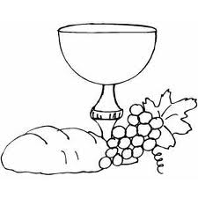

ALTAR OF REPOSE
In our parish, as noted, our Liturgy for the Last Supper will be celebrated in Sacred Heart Church beginning at 7:00pm on Holy Thursday. At the end of the Mass we will carry the Eucharist in procession around the church. The Eucharist will then be taken to Holy Cross Church to the “Altar of Repose.” The church will remain open until 10:00pm. During this period of time the Holy Name Society and the Altar Rosary Society will lead the prayers for adoration, Scripture Reading and the Rosary. All of our groups and people in ministry and indeed the entire parish, are encouraged to join in the prayer time, even if for a short while. There will be many people from other parishes visiting our church, most for a short period of time who are following in the tradition of “Visiting the Severn Churches on Holy Thursday.” Please be encouraged to visit the Lord in the Eucharist on this holy night when the Eucharist was instituted by Jesus.

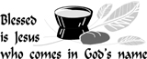

2024 HOLY WEEK SCHEDULE
Palm Sunday of the Lord’s Passion
March 23 ~ 24
~Blessing and Distribution of Palm~
Sacred Heart Church
Saturday Vigil at 5:15 pm
Sunday Mass 9:00 and 11:15 am
Holy Cross Church
Saturday Vigil at 4:00 pm
Sunday Mass 10:00 am (Gospel Mass),
12:00 noon (Polish)
Monday, Tuesday and Wednesday
Mass at 12:10 noon at Sacred Heart Church
Monday
Mass at 8:00 am at Holy Cross Church
Chrism Mass
March 25 – 7:30 pm
St. Robert Bellarmine Co-Cathedral,
61 Georgia Rd, Freehold, NJ
Holy Thursday
March 28th ~ 7:00 pm
Liturgy of the Lord’s Supper
7:00 pm at Sacred Heart Church, following the Mass the Eucharist will be taken to Holy Cross Church and placed in the Repository and will remain open till 10:00 pm. Sacred Heart Church will close after Mass.
Good Friday
March 29th
Liturgy of the Lord’s Passion
3:00 pm at Holy Cross Church
7:00 pm (Polish) at Holy Cross Church
Holy Saturday
March 30th
Service for the Blessing of Food
Holy Cross Church - 12:00 noon

Easter Vigil Liturgy
7:30 pm at Sacred Heart Church
Easter Sunday
March 31st
Sacred Heart Church 9:00 am and 11:15 am
Holy Cross Church 6:45 am (Polish), 10:00 am and 12:00 noon (Polish)

ALTAR ROSARY SOCIETY
All rosarians, future rosarians, people of our parish are warmly welcomed to join us on Sunday, April 7th, 9:00am Mass at Sacred Heart Church. The Rosary will be prayed before Mass. Following Mass a meeting will take place at Toomey Hall. Stop by, meet the members and enjoy light refreshments. We are a church support group of dedicated Catholic people who serve our Blessed Mother, our Parish community. We are looking forward to your participation. Any questions, please call Joan Buckley @ 609-396-7063.

“LITURGICAL LINES” OF HOLY WEEK

Monday through Thursday of Holy Week has precedence over all celebrations. Baptisms or Confirmations are not celebrated since they have their proper place in the Easter Vigil. Lent concludes before evening prayer on Holy Thursday. On Palm Sunday & Good Friday, the Passion of the Lord is read without candles, incense greeting or signing of the book. It may be read by lay readers, with the part of Christ, if possible, reserved to the priest. At the end of the reading, the book is not venerated with a kiss but “The Gospel of the Lord” is said with its response. A violet or red cloth may drape the cross or crucifix as well as the ambo from Palm Sunday through Good Friday.

Monday of Holy Week—In the Diocese of Trenton, the Bishop celebrates the Chrism Mass at the Co-Cathedral. During this Mass, the Holy Oils are consecrated and the priests renew their priestly commitment. The Holy Oils are brought to the parishes for the celebration of the sacraments.

The Sacred Triduum—During the Triduum, the Eucharist is distributed only during the liturgy, but may be brought to the sick at any hour. On Holy Saturday, the Eucharist is not given before the Easter Vigil. It may be given only as Viaticum (to the dying). Funeral Masses are not permitted, but a Liturgy of the Word with a Rite of Farewell is used. Holy Communion is not given.

Holy Thursday—Only the Mass of the Lord’s Supper is permitted. The tabernacle is empty and holy water is removed from all fonts. Votive lights before the saints are not lighted. Sufficient hosts are consecrated for the evening Mass and Good Friday. The group whose feet are washed should represent a cross section of the community. Following the Post-Communion Prayer, the Eucharist is brought to the place of reposition. Adoration follows. The altar is stripped following the liturgy. The liturgical color for Mass is white.

Good Friday—Good Friday is a day of fasting & abstinence and may continue until the Easter Vigil. The Celebration of the Lord’s Passion usually takes place about 3:00 PM. The General Intercessions and chants during the veneration of the cross are always sung. Only one cross is used for the veneration of the faithful. After the liturgy, the cross is placed in the sanctuary with four candles. The liturgical color is red.

Holy Saturday—The solemn vigil is celebrated after nightfall. The usual anticipated Sunday Masses are not celebrated. Nine readings are assigned for the Mass but these may be reduced with the account from Exodus always being read. Those receiving communion at the Vigil may receive on Easter Sunday. The liturgical color is white.

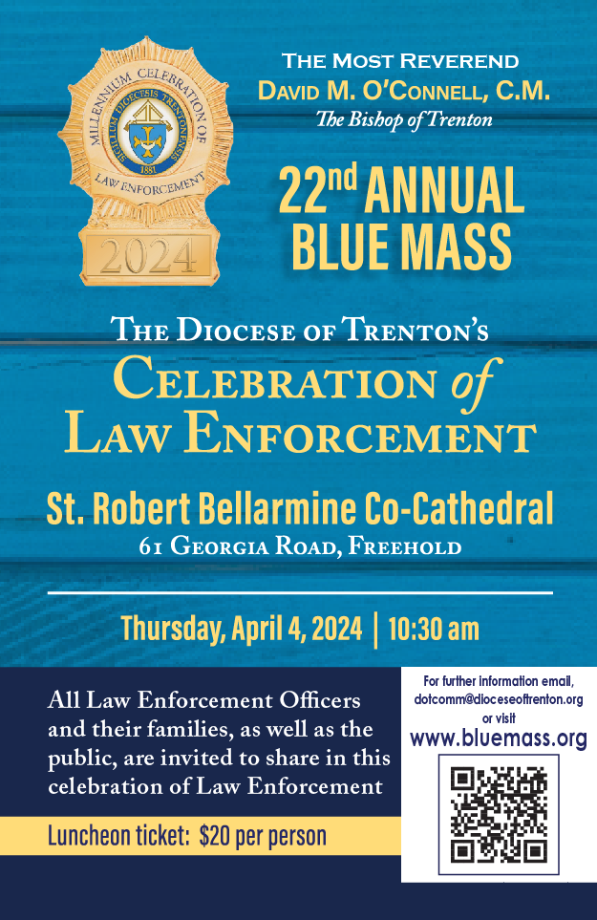

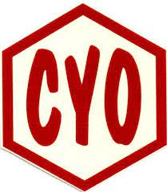

2024 MERCER COUNTY CYO
24th Golf Classic
Thursday, May 16, 2024
1:00 PM Shotgun
Mountain View
Golf Course
Bear Tavern Road
West Trenton, NJ

Honoring
Msgr. Dennis A. Apoldite
2024 CYO Man of the Year!

Golfers Registration: 11:00am
Shotgun Starts: 1:00pm
Lunch Served 11:30am to 12:45pm
Cocktails: 5:30pm
Buffet Dinner: 6:30pm

For More Information visit www.Trentonsacredheart.org
Or please call Pat at 609.585.4280 x102
Or email: phardiman@cyomercer.org

Dinner Guest only $50.00

Please be supportive of the tremendous work the CYO accomplishes in Mercer County.

